Building a FREE Virtual IT Lab at Home: A Simple Step-by-Step Guide

Creating a virtual IT lab is a great way to learn IT and cybersecurity skills—without needing expensive hardware. This guide will walk you through setting up your own completely free lab on your computer using open-source tools.

What You'll Need
- A computer (Windows, macOS, or Linux)
- Internet connection
- At least 8GB of RAM recommended
- Enough storage space for virtual machines (40GB+ recommended)

Step 1: Understanding Virtualization

Virtualization lets you run multiple "virtual computers" inside your main computer. Think of it as having **computers inside your computer**—each can run its own operating system and applications.

**Why it's useful for labs:**
- Safe environment to test software
- No risk to your main computer
- Easy to reset if something breaks

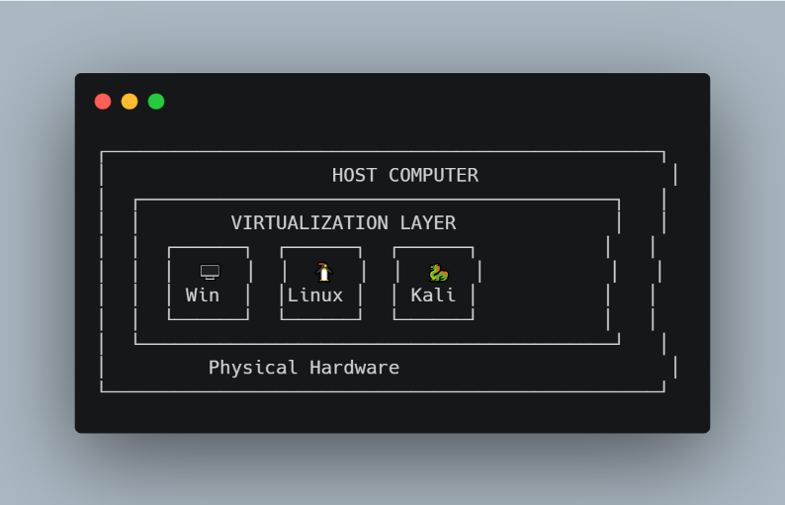

Step 2: Download & Install VirtualBox

We'll use **Oracle VM VirtualBox**—it's free and works on all major operating systems.

1. Go to: **https://www.virtualbox.org/wiki/Downloads**
2. Download the version for your operating system.
3. Run the installer and accept all **default options**.

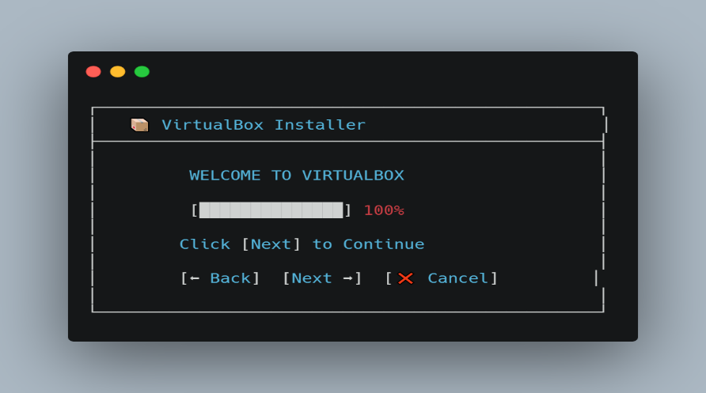

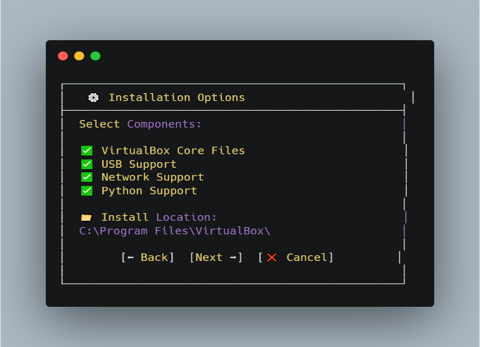

4. Click **Finish** and launch VirtualBox.

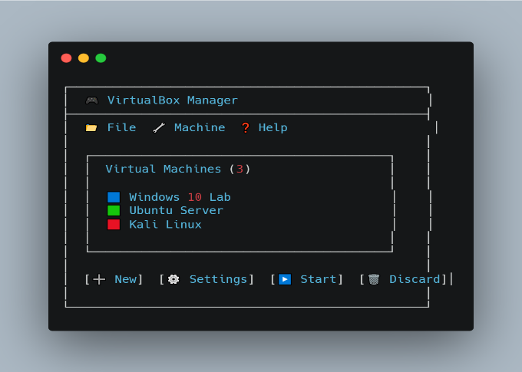
---

Step 3: Create Your First Virtual Machine

1. Click the **"New"** button.
2. Enter a name for your VM (e.g., "Windows 10 Lab").
3. Select the operating system type and version.
4. Allocate **RAM**—2048 MB (2GB) is a good starting point.
5. Choose **"Create a virtual hard disk now"**.

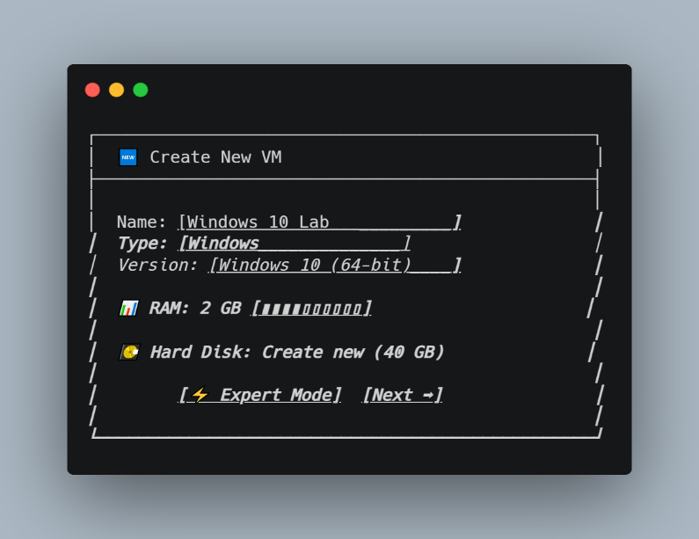

6. Choose **VDI** as the hard disk type.
7. Select **"Dynamically allocated"**.
8. Set the hard disk size—**40GB** is a good default.

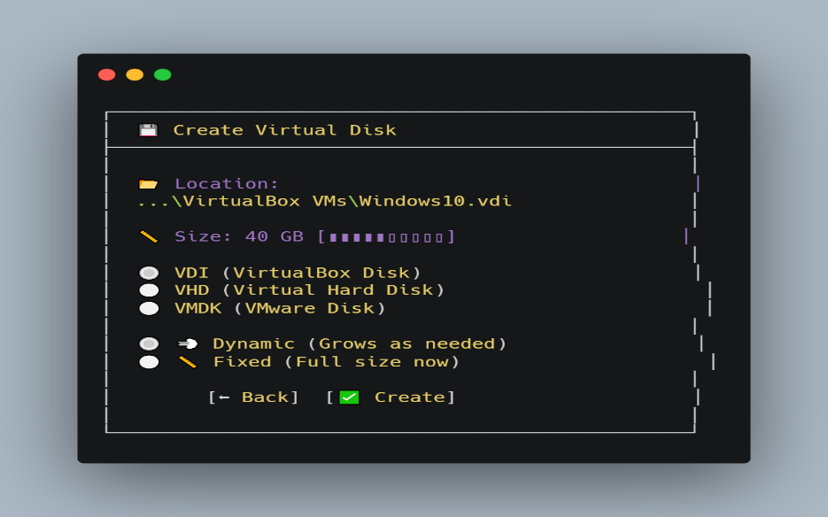

Step 4: Configure Your Virtual Network

VirtualBox offers several network types. For most labs, **NAT Network** is recommended—it lets VMs talk to each other and access the internet.

To set up a NAT Network:
1. Go to **File → Preferences → Network**.
2. Click the **+** button to create a new NAT network.
3. In your VM's settings, go to **Network** and select **"Attached to: NAT Network"**.

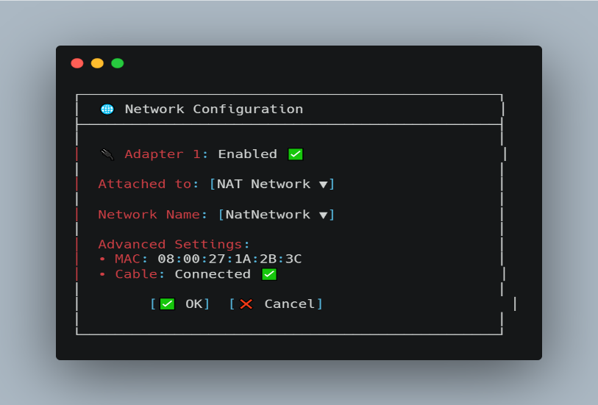
Other network types:
**Bridged**: VM acts like a separate device on your home network.
**Internal**: Isolated network between VMs only.
**Host-only**: VM can talk to your host computer but not the internet.

Step 5: Download an Operating System (ISO)

You'll need an ISO file—a digital copy of an operating system.

Recommended official sources:
Windows 10/11**: https://www.microsoft.com/software-download
Ubuntu**: https://ubuntu.com/download/desktop
Kali Linux**: https://www.kali.org/downloads/

⚠️ only download from official sites to avoid malware.

**Step 6: Mount the ISO & Install the OS**

1. Right-click your VM and select **Settings**.
2. Go to **Storage**.
3. Click the **empty CD/DVD icon**.
4. Click the **disc icon** under **Attributes**.
5. Choose **"Choose Virtual Optical Disk File..."** and select your ISO.

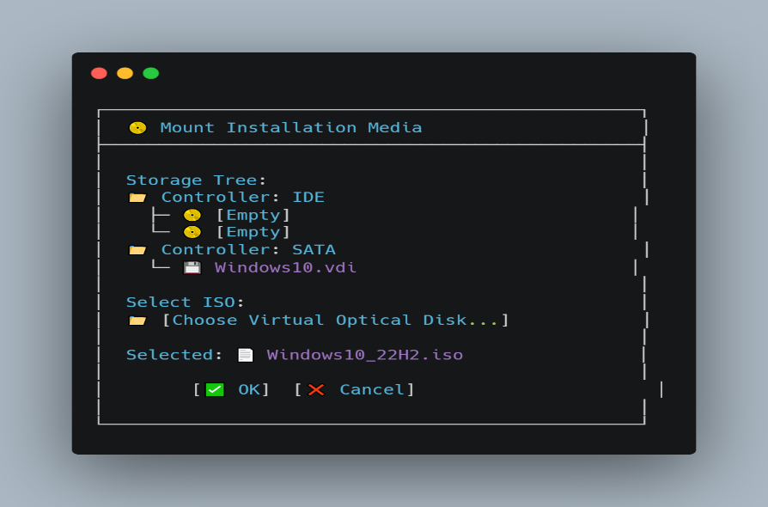
6. Click **OK**, then start your VM.
7. The OS installation will begin—follow the on-screen prompts.
## **Step 7: Optimize Your VM (Optional)**

For better performance:
- In VM **Settings → System → Processor**, increase CPU cores to **2**.
- Store VM files on an **SSD** if possible.
- Install VirtualBox **Guest Additions** for better integration.

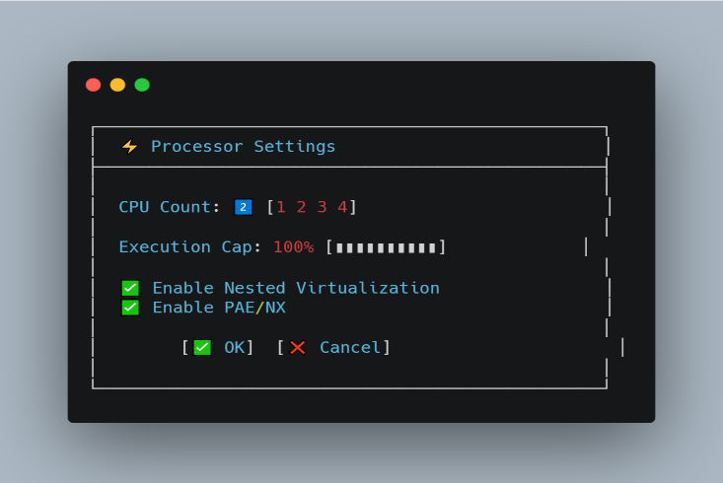

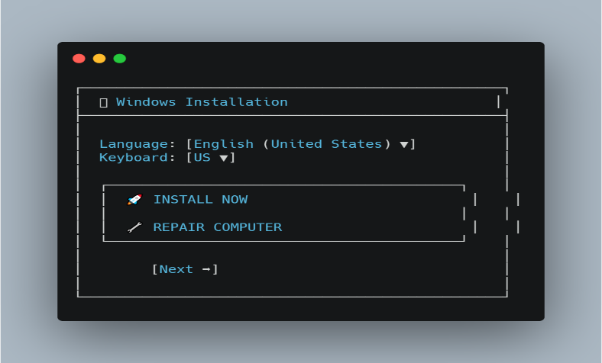
**🎉 You're Done!**

You now have a fully functional virtual IT lab. You can create more VMs, set up networks, install servers, test software, or practice cybersecurity—all in a safe, virtual environment.

### **What you've accomplished:**
- ☑ Installed VirtualBox
- ☑ Created a virtual machine
- ☑ Set up a virtual network
- ☑ Downloaded and mounted an OS
- ☑ Installed an operating system

Now go explore, experiment, and build your skills—all from your own computer.

